Bahria University,

Karachi Campus



LAB EXPERIMENT NO.05

LIST OF TASKS

|  |  |
| --- | --- |
| TASK NO | OBJECTIVE |
|  |
|  | 1. **Take 4 switches named as: A, B, C, D and connect them in alphabetical order.**   **Perform and show the following configurations in your lab task:**   * 1. Switch A with VLANs faculty and students having 1 logical port each.   2. Now assign 1 logical port each to VLANs faculty and students in Switch B and D.   3. Now make switch A in server mode, whereas B and D in client mode and switch C in transparent mode.   4. Assign IP addresses to PCs connected to Switch A, B and D.   5. Now ping within the same VLAN and outside the same VLAN and show your results. |
|  |  |
|  |  |

Submitted On:

Date: 3/10/22

1. **Take 4 switches named as: A, B, C, D and connect them in alphabetical order.**

**Perform and show the following configurations in your lab task:**

* 1. Switch A with VLANs faculty and students having 1 logical port each.

**Faculty and Students:**

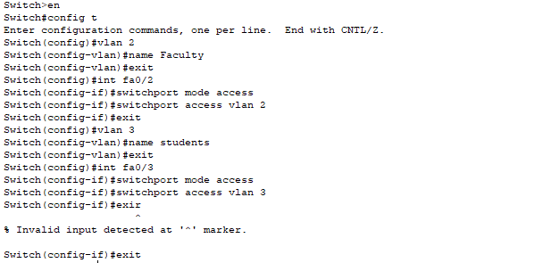

**Trunk Mode:**

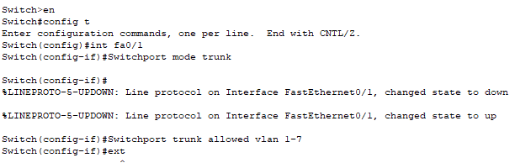

* 1. Now assign 1 logical port each to VLANs faculty and students in Switch B and D.

**Faculty and Students in Switch B:**

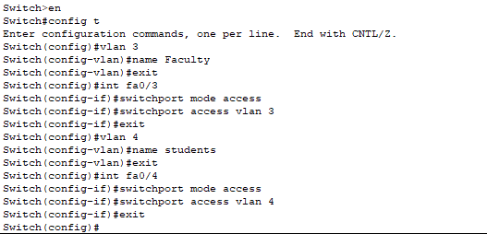

**Faculty and Students in Switch D:**

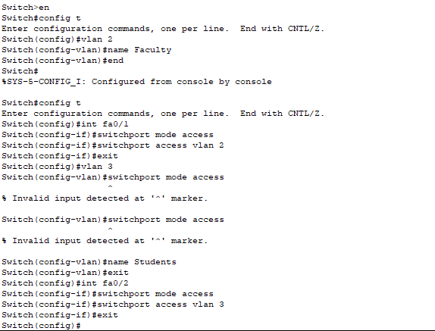

**Trunk Mode:**

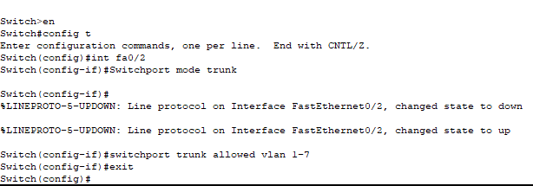 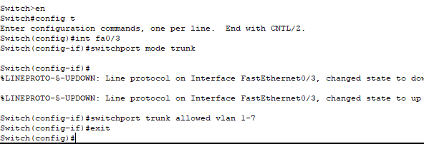

* 1. Now make switch A in server mode, whereas B and D in client mode and switch C in transparent mode.

**Switch A:**

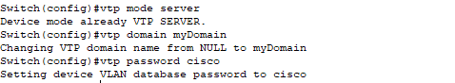

**Switch B:**

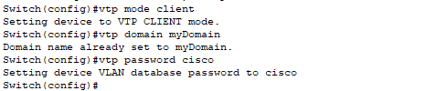

**Switch C:**

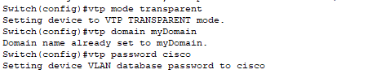

**Switch D:**

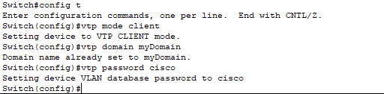

* 1. Assign IP addresses to PCs connected to Switch A, B and D.

**Switch A:**

 

**Switch B:**

 

**Switch D:**

 

* 1. Now ping within the same VLAN and outside the same VLAN and show your results.

**With Same Vlan:**

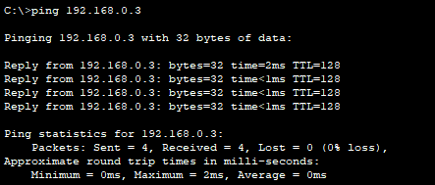

**With Different Vlan:**

